Работу выполнил Чепоков Елизар в группе с Кролевицкой Ариной и Ануфриевым Павлом

Ниже представлен код программы и вывод для каждой задачи

Задание было выполнено с помощью Oracle Live SQL

Так же задание можно найти на github: <https://gist.github.com/Bloodies/074482e5add7742a1ded28eb6198643c> (на случай если код в документе побился и читается с ошибкой)

DROP TABLE JT$Calendar;

create table JT$Calendar --инициализация

(Cal_Day date not null);

insert into JT$Calendar(Cal_Day) values (to_date('01.01.2009', 'dd.mm.yyyy'));

insert into JT$Calendar(Cal_Day) values (to_date('02.01.2009', 'dd.mm.yyyy'));

insert into JT$Calendar(Cal_Day) values (to_date('03.01.2009', 'dd.mm.yyyy'));

insert into JT$Calendar(Cal_Day) values (to_date('04.01.2009', 'dd.mm.yyyy'));

insert into JT$Calendar(Cal_Day) values (to_date('05.01.2009', 'dd.mm.yyyy'));

insert into JT$Calendar(Cal_Day) values (to_date('06.01.2009', 'dd.mm.yyyy'));

insert into JT$Calendar(Cal_Day) values (to_date('07.01.2009', 'dd.mm.yyyy'));

insert into JT$Calendar(Cal_Day) values (to_date('08.01.2009', 'dd.mm.yyyy'));

insert into JT$Calendar(Cal_Day) values (to_date('09.01.2009', 'dd.mm.yyyy'));

insert into JT$Calendar(Cal_Day) values (to_date('10.01.2009', 'dd.mm.yyyy'));

insert into JT$Calendar(Cal_Day) values (to_date('11.01.2009', 'dd.mm.yyyy'));

insert into JT$Calendar(Cal_Day) values (to_date('12.01.2009', 'dd.mm.yyyy'));

insert into JT$Calendar(Cal_Day) values (to_date('13.01.2009', 'dd.mm.yyyy'));

insert into JT$Calendar(Cal_Day) values (to_date('14.01.2009', 'dd.mm.yyyy'));

insert into JT$Calendar(Cal_Day) values (to_date('15.01.2009', 'dd.mm.yyyy'));

insert into JT$Calendar(Cal_Day) values (to_date('16.01.2009', 'dd.mm.yyyy'));

insert into JT$Calendar(Cal_Day) values (to_date('17.01.2009', 'dd.mm.yyyy'));

insert into JT$Calendar(Cal_Day) values (to_date('18.01.2009', 'dd.mm.yyyy'));

insert into JT$Calendar(Cal_Day) values (to_date('19.01.2009', 'dd.mm.yyyy'));

insert into JT$Calendar(Cal_Day) values (to_date('20.01.2009', 'dd.mm.yyyy'));

insert into JT$Calendar(Cal_Day) values (to_date('21.01.2009', 'dd.mm.yyyy'));

insert into JT$Calendar(Cal_Day) values (to_date('22.01.2009', 'dd.mm.yyyy'));

insert into JT$Calendar(Cal_Day) values (to_date('23.01.2009', 'dd.mm.yyyy'));

insert into JT$Calendar(Cal_Day) values (to_date('24.01.2009', 'dd.mm.yyyy'));

insert into JT$Calendar(Cal_Day) values (to_date('25.01.2009', 'dd.mm.yyyy'));

insert into JT$Calendar(Cal_Day) values (to_date('26.01.2009', 'dd.mm.yyyy'));

insert into JT$Calendar(Cal_Day) values (to_date('27.01.2009', 'dd.mm.yyyy'));

insert into JT$Calendar(Cal_Day) values (to_date('28.01.2009', 'dd.mm.yyyy'));

insert into JT$Calendar(Cal_Day) values (to_date('29.01.2009', 'dd.mm.yyyy'));

insert into JT$Calendar(Cal_Day) values (to_date('30.01.2009', 'dd.mm.yyyy'));

insert into JT$Calendar(Cal_Day) values (to_date('31.01.2009', 'dd.mm.yyyy'));

select * from JT$Calendar;

DROP TABLE JT$Emp;

create table JT$Emp --инициализация таблицы

( Empno number not null, -- Таб. номер

EName varchar2 (80) not null, -- Имя

Job varchar2 (30) not null, -- Должность

Mgr number, -- Начальник

Hiredate date not null, -- Дата приема

Sal number (10, 2) not null, -- Оклад

Comm number (10, 2), -- Бонус

Deptno number not null -- Отдел

);

insert into JT$Emp(Empno, EName, Job, Mgr, Hiredate, Sal, Comm, Deptno) values (7369, 'SMITH', 'CLERK', 7902, to_date('17.12.2007', 'dd.mm.yyyy'), 800, null, 20);

insert into JT$Emp(Empno, EName, Job, Mgr, Hiredate, Sal, Comm, Deptno) values (7499, 'ALLEN', 'SALESMAN', 7698, to_date('20.02.2005', 'dd.mm.yyyy'), 1600, 300, 30);

insert into JT$Emp(Empno, EName, Job, Mgr, Hiredate, Sal, Comm, Deptno) values (7521, 'WARD', 'SALESMAN', 7698, to_date('22.01.2009', 'dd.mm.yyyy'), 1250, 500, 30);

insert into JT$Emp(Empno, EName, Job, Mgr, Hiredate, Sal, Comm, Deptno) values (7566, 'JONES', 'MANAGER', 7839, to_date('02.04.2006', 'dd.mm.yyyy'), 2975, null, 20);

insert into JT$Emp(Empno, EName, Job, Mgr, Hiredate, Sal, Comm, Deptno) values (7654, 'MARTIN', 'SALESMAN', 7698, to_date('28.09.2008', 'dd.mm.yyyy'), 1250, 1400, 30);

insert into JT$Emp(Empno, EName, Job, Mgr, Hiredate, Sal, Comm, Deptno) values (7698, 'BLAKE', 'MANAGER', 7839, to_date('15.01.2009', 'dd.mm.yyyy'), 2850, null, 30);

insert into JT$Emp(Empno, EName, Job, Mgr, Hiredate, Sal, Comm, Deptno) values (7782, 'CLARK', 'MANAGER', 7839, to_date('09.06.2000', 'dd.mm.yyyy'), 2450, null, 10);

insert into JT$Emp(Empno, EName, Job, Mgr, Hiredate, Sal, Comm, Deptno) values (7839, 'KING', 'PRESIDENT', null, to_date('17.11.2005', 'dd.mm.yyyy'), 5000, null, 10);

insert into JT$Emp(Empno, EName, Job, Mgr, Hiredate, Sal, Comm, Deptno) values (7844, 'TURNER', 'SALESMAN', 7698, to_date('11.01.2009', 'dd.mm.yyyy'), 1500, 0, 30);

insert into JT$Emp(Empno, EName, Job, Mgr, Hiredate, Sal, Comm, Deptno) values (7900, 'JAMES', 'CLERK', 7844, to_date('03.12.2001', 'dd.mm.yyyy'), 950, null, 30);

insert into JT$Emp(Empno, EName, Job, Mgr, Hiredate, Sal, Comm, Deptno) values (7902, 'FORD', 'ANALYST', 7566, to_date('11.01.2009', 'dd.mm.yyyy'), 3000, null, 20);

insert into JT$Emp(Empno, EName, Job, Mgr, Hiredate, Sal, Comm, Deptno) values (7934, 'MILLER', 'CLERK', 7782, to_date('23.01.2004', 'dd.mm.yyyy'), 1300, null, 10);

select * from JT$Emp;

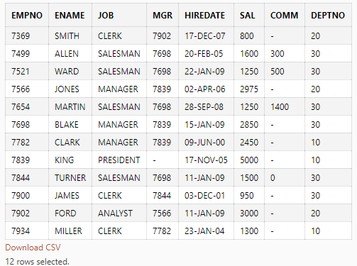

DROP TABLE JT$Operations;

create table JT$Operations --инициализация таблицы с шефами

( Operation_Id number not null, -- Id операции

Account_Id number not null, -- Id счета

Operation_Type varchar2 (2) not null /*CHECK (Operation_Type in ('D', 'C'))*/, -- Тип операции

Operation_Date date not null, -- Дата операции

Agreement_Num varchar2 (20), -- Номер договора

Amount number (20, 2) not null -- Сумма операции

);

insert into JT$Operations(Operation_Id, Account_Id, Operation_Type, Operation_Date, Agreement_Num, Amount) values (1, 1, 'С', to_date('01.01.2009', 'dd.mm.yyyy'), null, 100);

insert into JT$Operations(Operation_Id, Account_Id, Operation_Type, Operation_Date, Agreement_Num, Amount) values (2, 1, 'С', to_date('01.01.2009', 'dd.mm.yyyy'), '01-11A', 230);

insert into JT$Operations(Operation_Id, Account_Id, Operation_Type, Operation_Date, Agreement_Num, Amount) values (3, 1, 'С', to_date('01.01.2009', 'dd.mm.yyyy'), '01-11B', 350);

insert into JT$Operations(Operation_Id, Account_Id, Operation_Type, Operation_Date, Agreement_Num, Amount) values (4, 1, 'D', to_date('01.01.2009', 'dd.mm.yyyy'), null, 100);

insert into JT$Operations(Operation_Id, Account_Id, Operation_Type, Operation_Date, Agreement_Num, Amount) values (5, 1, 'D', to_date('01.01.2009', 'dd.mm.yyyy'), null, 100);

insert into JT$Operations(Operation_Id, Account_Id, Operation_Type, Operation_Date, Agreement_Num, Amount) values (6, 1, 'D', to_date('01.01.2009', 'dd.mm.yyyy'), '01-11A', 150);

insert into JT$Operations(Operation_Id, Account_Id, Operation_Type, Operation_Date, Agreement_Num, Amount) values (7, 1, 'D', to_date('01.01.2009', 'dd.mm.yyyy'), '01-11A', 150);

insert into JT$Operations(Operation_Id, Account_Id, Operation_Type, Operation_Date, Agreement_Num, Amount) values (8, 1, 'С', to_date('01.01.2009', 'dd.mm.yyyy'), null, 500);

insert into JT$Operations(Operation_Id, Account_Id, Operation_Type, Operation_Date, Agreement_Num, Amount) values (9, 1, 'С', to_date('01.01.2009', 'dd.mm.yyyy'), null, 327);

select * from JT$Operations;

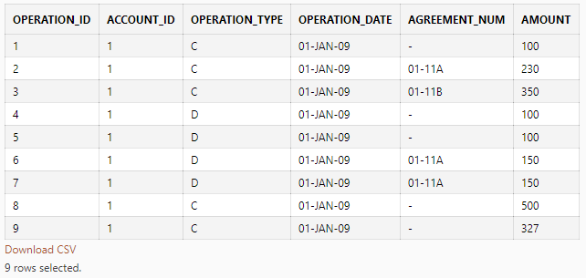

DROP TABLE JT$Saldo;

create table JT$Saldo --инициализация таблицы

( Customer_Id number not null, -- Id клиента

Account_Id number not null, -- Id счета

Beg_Date date not null, -- Дата начала действия

End_Date date not null, -- Дата конца действия

Out_Saldo number (20, 2) not null -- Исходящий остаток

);

insert into JT$Saldo(Customer_Id, Account_Id, Beg_Date, End_Date, Out_Saldo) values (1, 1, to_date('01.12.2008', 'dd.mm.yyyy'), to_date('19.12.2008', 'dd.mm.yyyy'), 100);

insert into JT$Saldo(Customer_Id, Account_Id, Beg_Date, End_Date, Out_Saldo) values (1, 1, to_date('20.12.2008', 'dd.mm.yyyy'), to_date('21.12.2008', 'dd.mm.yyyy'), 180);

insert into JT$Saldo(Customer_Id, Account_Id, Beg_Date, End_Date, Out_Saldo) values (1, 1, to_date('22.12.2008', 'dd.mm.yyyy'), to_date('31.12.2008', 'dd.mm.yyyy'), 83.50);

insert into JT$Saldo(Customer_Id, Account_Id, Beg_Date, End_Date, Out_Saldo) values (1, 1, to_date('01.01.2009', 'dd.mm.yyyy'), to_date('09.01.2009', 'dd.mm.yyyy'), -923.70);

insert into JT$Saldo(Customer_Id, Account_Id, Beg_Date, End_Date, Out_Saldo) values (1, 1, to_date('10.01.2009', 'dd.mm.yyyy'), to_date('31.12.9999', 'dd.mm.yyyy'), 0.32);

insert into JT$Saldo(Customer_Id, Account_Id, Beg_Date, End_Date, Out_Saldo) values (1, 2, to_date('08.12.2008', 'dd.mm.yyyy'), to_date('19.12.2008', 'dd.mm.yyyy'), 10);

insert into JT$Saldo(Customer_Id, Account_Id, Beg_Date, End_Date, Out_Saldo) values (1, 2, to_date('20.12.2008', 'dd.mm.yyyy'), to_date('20.12.2008', 'dd.mm.yyyy'), 120);

insert into JT$Saldo(Customer_Id, Account_Id, Beg_Date, End_Date, Out_Saldo) values (1, 2, to_date('21.12.2008', 'dd.mm.yyyy'), to_date('04.01.2009', 'dd.mm.yyyy'), 63.10);

insert into JT$Saldo(Customer_Id, Account_Id, Beg_Date, End_Date, Out_Saldo) values (1, 2, to_date('05.01.2009', 'dd.mm.yyyy'), to_date('24.01.2009', 'dd.mm.yyyy'), 1200);

insert into JT$Saldo(Customer_Id, Account_Id, Beg_Date, End_Date, Out_Saldo) values (1, 2, to_date('25.01.2009', 'dd.mm.yyyy'), to_date('31.12.9999', 'dd.mm.yyyy'), 1003.31);

select * from JT$Saldo;

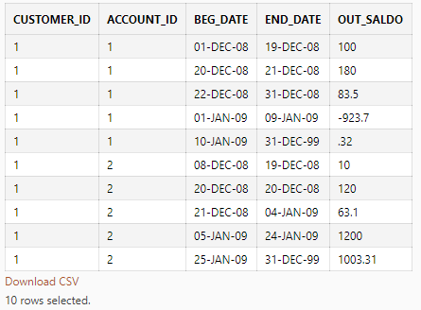

--1(1)-Задание---------------------------------------------------------------------------------------------------------------

/*Написать SQL-запрос, выбирающий из таблицы JT$Emp следующие данные для отчета по подразделениям (ниже перечислены столбцы):

· Номер подразделения (Deptno).

· Общее число сотрудников подразделения.

· Число сотрудников подразделения, принятых на работу (Hiredate) в январе 2009 г.

· Суммарный оклад (Sal) всех сотрудников подразделения.

· Процентная доля оклада сотрудников подразделения, принятых на работу (Hiredate) в январе 2009 г., в суммарном окладе сотрудников подразделения.*/

-----------------------------------------------------------------------------------------------------------------------------

select distinct Deptno "Номер подразделения",

count(1) "Количество сотрудников",

sum(case when 1=1 and Hiredate >= to_date('01.01.2009', 'dd.mm.yyyy') and Hiredate <= to_date('31.01.2009', 'dd.mm.yyyy') then 1 else 0 end) "поступило в январе 2009",

sum(Sal) "Суммарный оклад сотрудников",

nvl(trunc((select sum(sal) from jt$emp jan where 1=1 and jan.hiredate >= to_date('01.01.2009', 'dd.mm.yyyy') and jan.hiredate <= to_date('31.01.2009', 'dd.mm.yyyy') and jan.deptno=emp.deptno)/ sum(emp.sal) * 100, 2), 0) "Процентная доля оклада работников, принятых в январе"

from jt$emp emp where 1=1 group by Deptno order by Deptno;

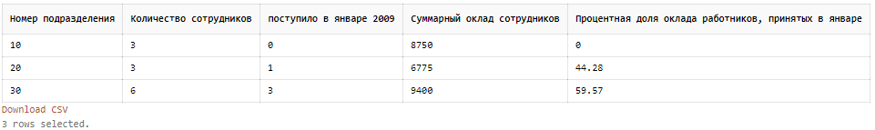

--1(2)-Задание---------------------------------------------------------------------------------------------------------------

/*Выбрать аналогичные данные по сотрудникам,

подчиненным (как непосредственно, так и опосредованно, по иерархии подчинения)

заданному сотруднику (использовать номер сотрудника 7698).

Идентификатор (Empno) непосредственного руководителя сотрудника содержится в поле Mgr.*/

-----------------------------------------------------------------------------------------------------------------------------

select distinct Deptno "номер подразделения",

count(1) "количество сотрудников",

sum(case when 1=1 and Hiredate >= to_date('01.01.2009', 'dd.mm.yyyy') and Hiredate <= to_date('31.01.2009', 'dd.mm.yyyy') then 1 else 0 end) "поступило в январе 2009",

sum(Sal) "суммарный оклад сотрудников",

nvl(trunc((select sum(sal) from jt$emp jan where 1=1 and jan.hiredate >= to_date('01.01.2009', 'dd.mm.yyyy') and jan.hiredate <= to_date('31.01.2009', 'dd.mm.yyyy') and jan.deptno=emp.deptno and jan.mgr IN (select mgrs.empno from jt$emp mgrs where 1=1 and (mgrs.empno = 7698 or mgrs.mgr = 7698)))/ sum(Sal) * 100,2),0) "процентная доля оклада работников, принятых в январе"

from jt$emp emp where 1=1 and Mgr IN (select mgrs.empno from jt$emp mgrs where 1=1 and (mgrs.empno = 7698 or mgrs.mgr = 7698 ))

group by Deptno order by Deptno;



--2-Задание-----------------------------------------------------------------------------------------------------------------

/*Написать SQL – запрос, выбирающий из таблицы JT$Operations данные для отчета*/

-----------------------------------------------------------------------------------------------------------------------------

create or replace function PromTable

(

p_account_id int,

p_dateFrom date,

p_dateTo date

)

RETURN TABLE is

Account_Id int;

Operation_Date date;

Agreement_Num varchar(20);

Operation_Id_db int;

Amount_db numeric(20, 2);

Operation_Id_cr int;

Amount_cr numeric(20, 2);

new_Operation_Date date;

new_Agreement_Num varchar(50);

CURSOR c_cursor

is SELECT distinct Operation_Date, isnull(Agreement_Num, '') as Agreement_Num

FROM JT$Operations

WHERE Account_Id = p_account_id and Operation_Date >= p_dateFrom and Operation_Date <= p_dateTo;

OPEN c_cursor;

BEGIN

loop

FETCH c_cursor INTO new_Operation_Date, new_Agreement_Num;

exit when c_cursor%NOTFOUND;

end loop;

loop

--INSERT INTO Finance

select isnull(db.Account_Id, cr.Account_Id) Account_Id,

isnull(db.Operation_Date, cr.Operation_Date) Operation_Date,

isnull(db.Agreement_Num, cr.Agreement_Num) Agreement_Num,

db.Operation_Id,

db.Amount,

cr.Operation_Id,

cr.Amount

from

( SELECT ROW_NUMBER() OVER (Order by Operation_Id) AS RowNumber, Operation_Date, isnull(Agreement_Num, '') as Agreement_Num, Operation_Id, Amount, Account_Id

FROM JT$Operations

WHERE Operation_Type = 'D' and isnull(Agreement_Num, '') = new_Agreement_Num and Operation_Date = new_Operation_Date

) db

full JOIN

( SELECT ROW_NUMBER() OVER (Order by Operation_Id) AS RowNumber, Operation_Date, isnull(Agreement_Num, '') as Agreement_Num, Operation_Id, Amount, Account_Id

FROM JT$Operations

WHERE Operation_Type = 'C' and isnull(Agreement_Num, '') = new_Agreement_Num and Operation_Date = new_Operation_Date

) cr

ON db.RowNumber = cr.RowNumber;

FETCH c_cursor INTO new_Operation_Date, new_Agreement_Num;

end loop;

CLOSE c_cursor;

return;

end PromTable;

declare new_Account_Id int;

declare new_p_dateFrom date;

declare new_p_dateTo date;

set new_Account_Id = 1;

set new_p_dateFrom = CAST(to_date('01.01.2009', 'dd.mm.yyyy'));

set new_p_dateTo = CAST(to_date('02.01.2009', 'dd.mm.yyyy'));

select * from GetFinanceTable(new_Account_Id, new_p_dateFrom, new_p_dateTo)

order by Operation_date, Agreement_num